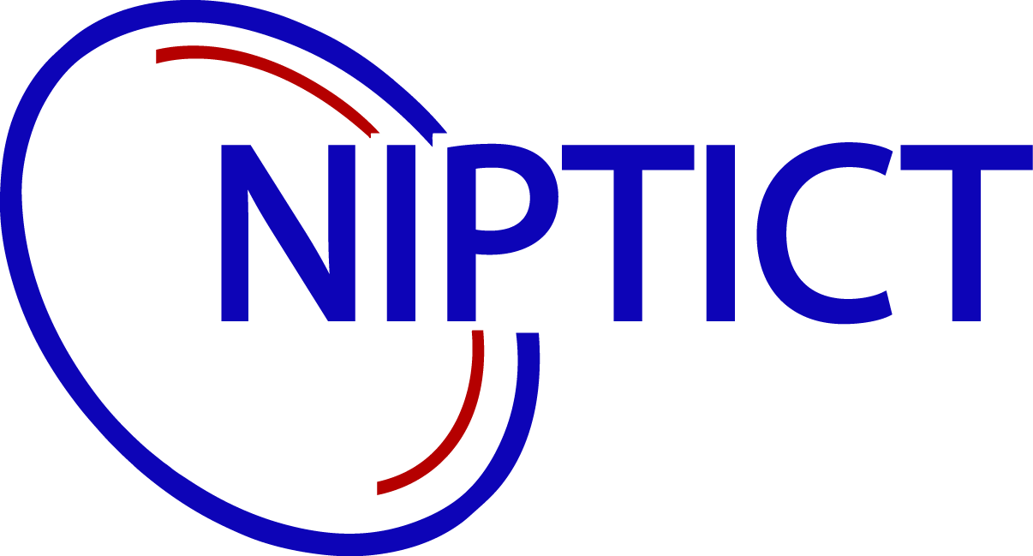

វិទ្យាស្ថានប្រៃសណីយ៏ទូគមនាគមន៏ បច្ចេកវិទ្យាគមនាគមន៏ និង ព័ត៏មាន

National Institute of Post, Telecoms And ICT

មហាវិទ្យាល័យ វិទ្យាសាស្ដ្រកុំព្យូទ័រ

School of Computer Science(CS)

Lectured by: PHAN CHANREAKSMEY

Phnom Penh

ABSTRACTS

This report is a demonstration of our project experience and the work that we have done for 6 weeks also In

class task. During project has been assigned by teacher, we build a team up with classmate that collaborate with team

to build up this project exactly. We have worked with project called “ ដើមឈើ ” in Khmer version and “E-Tree” in English version. This web application, People or citizen of Cambodia can purchase the tree that we want and donation

also.

Currently, our country seems lack the tree and data’s down, therefore we are from group3 has decided this concept and

Build it up on web application to make people easy to buy the tree and donate also to our country. Particularly wood is

A main of nature that can protect us to flooded or something that is occurred by lack the wood or tree, as we saw now

On the world is down and many floods is destroying people and it can make to virus or something that can destroy us.

We are developing a web application and response for all such as backend, frontend also. Especially we are thinking

About business strategy to get helpful from it also.

I wish It was very useful for guys and our society also and can help people from problems that will happened

On the world.

TEAM LIST NAME

1. SREY VOTANA ស្រី វត្តនា

2. SEOUN OSSA សឿន ឧស្សាយ៏

3. SONG KEMENG សុង កេមេង

ABBREVIATION AND SYMBOLS

|  |  |
| --- | --- |
| NAME | STAND FOR |
| HTML | Hypertext Makeup Language |
| CSS | Cascading Style Sheets |
| JS | JavaScript |
| GUI | Graphical User Interface |
| MVC | Model View Controller |
| MySQL | My Structure Query Language |
| UI/UX | User Interface/ User Experience |

Content

1. About Web Tree
2. Use case diagram
3. Data diagram
4. Use Technologies
5. Project schedule
6. UX/UI design
7. Difficulties
8. Conclusion
9. About Web Tree

Here in E-tree we care so much about trees as well as our environment. Because of how bad our environment we’re living in is right now, we want to make it better, for us and our future generations. Our goal is for everybody to know more and better about environment. You can learn many things about environment, such as planting trees, how to take care of trees, how to grow them and many more. We take no charges in our learning courses. We also sell many kinds of tree for you to plant them yourselves. Other than that, we also accept donations to help our environment. We will use the funds we raised to plant more trees, improve our programs as well as hire more workers. Every dollar you give, a tree will be grown. Now a day, on the Earth we lost many tree because many people have destroy the tree that why we have to do something to help our planet to be good like we join to plant the tree and we have to take care the environment. In our web, everyone can learn about the tree, environment, and we can learn how to plant the tree good because plant tree it not like play toy. If we not plant the tree perfectly that tree will not grows up well and sometime it not grows up. We have a lot of reason that why for our team we have to create one web that is very easy for every people to join for learning about the tree, join to know about our planet, order the tree on our web site and everyone can donate the tree or the money for help to plant the tree in our society or for the world.

1. Use Case Diagram

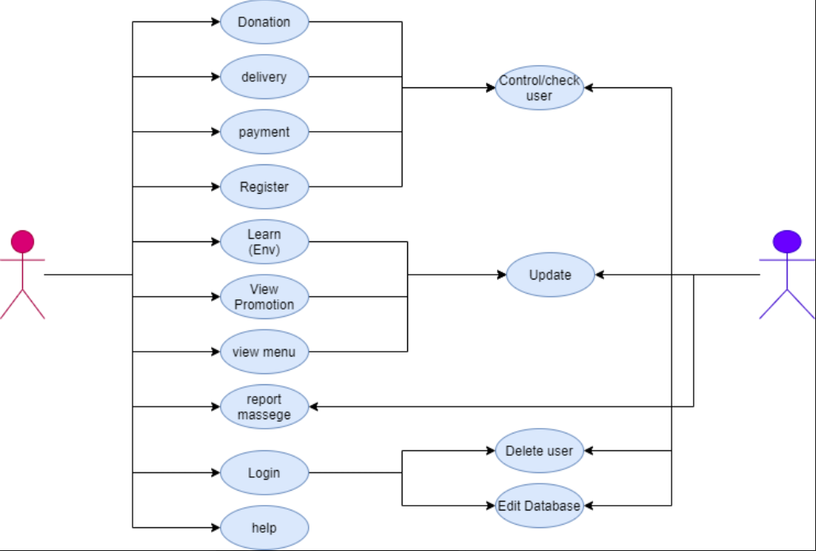

User is the type of user that can make account and report or Comment on other post from website. Admin is the most powerful type of user can control on user can delete account user, upload new or post and can use all features.

1. Database Diagram

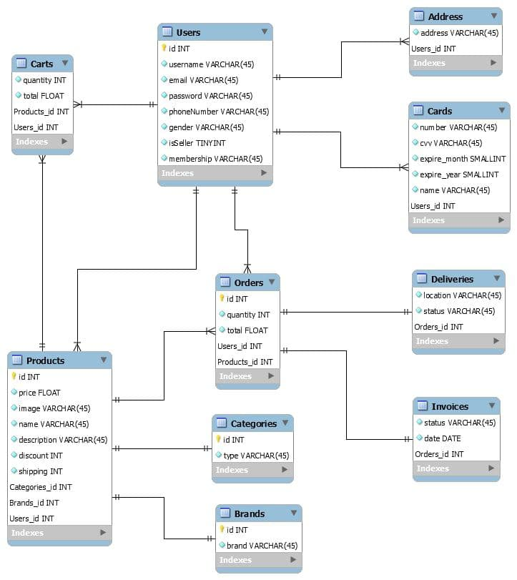

We use MySQL Workbench to create the diagram because it easy to use. After that we have to connect to PhpMyAdmin with Wamp64 or Xampp to display Database.

1. Use Technologies

Laravel is the framework of php.Laravel attempts to take the pain out of development by easing common tasks used in the majority of web projects, such as authentication, routing, sessions, and caching. Laravel aims to make the development process a pleasing one for the developer without sacrificing application functionality.

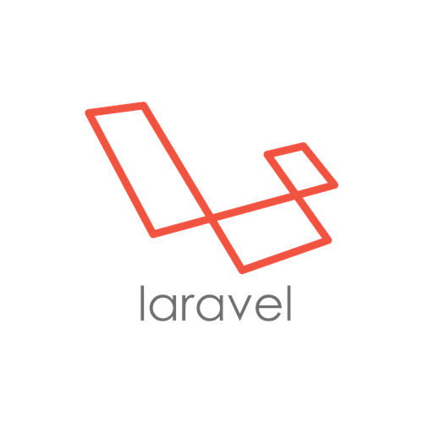

1. Language and Libraries

HTML: Hypertext Markup Language, is a standardized system for tagging text files to achieve font, color, graphic, and hyperlink effects on World Wide pages. We choose it because it is fundamental web page building script.

CSS: is a simple design language intended to simplify the process of making web page presentable by define how to display HTML elements. use it to style and make our website responsive.

Bootstrap: is a sleek, intuitive, and powerful mobile first front- end framework for faster and easier web development that uses HTML, CSS and JavaScript. We use it for mobile responsiveness.

 **Visual Studio Code** is a streamlined **code** editor with support for development operations like debugging, task running, and version control. It aims to provide just the tools a developer needs for a quick **code**-build-debug cycle and leaves more complex workflows to fuller featured IDEs, such as Visual Studio IDE

**GitHub** is a code hosting platform for version control and collaboration. It lets you and others work together on projects from anywhere. This tutorial teaches you **GitHub** essentials like repositories, branches, commits, and Pull Requests.

Google Chrome: is a powerful web browser that we choose for amazing browsing speed and contains concrete developer tool is great for debugging code.

 XD: is used for designed screens.

1. Project Schedule

The following table demonstrates my plan during 6 weeks of E-Tree website project.

|  |  |  |  |  |  |  |
| --- | --- | --- | --- | --- | --- | --- |
| Task/week | 1 | 2 | 3 | 4 | 5 | 6 |
| Learning/Team up |  |  |  |  |  |  |
| Database Design |  |  |  |  |  |  |
| UX/UI Design |  |  |  |  |  |  |
| Implementation |  |  |  |  |  |  |
| Testing |  |  |  |  |  |  |
|  |  |  |  |  |  |  |

1. UX/UI Design

This is UX/UI design in E-Tree project for our Team to make it comfortable.

|  |  |
| --- | --- |
|  |  |
|  | Enroll: User can register with Email, PS, etc. |
|  | Login: User can login their info. |
|  | Donate: User can donate the tree or money for KH. |
| User | Purchasing: User can buy the tree. |
|  | E-Learning: User can learn or research. |
|  | Contact: User can be contacted. |
|  | Feedback and comment: User can feed the quantity website. |
|  |  |
|  | Slide show |
|  | Text bar |
|  | Home page |
| System | Footer |
|  | Video material |
|  | List name of the tree and description |
|  | Design Database |
|  |  |

1. Difficulties

In our web site we have some difficult to make the web site because using Laravel is the first time have use that and we don’t have much time to study about it clearly and it hard to use it. And one more thing it is Back-End is difficult to connect to database we have take a lot of time to learn about it.

1. Conclusion

In conclusion, we would to thank you our school (NIPTICT) and teacher to help our team to do this project successful for our web site. It is not perfectly but it is our first learn to do this web site. In this project we can learn a lot of code that is new for our team and we know a new code and a new framework to create the web site and we got some experience to create one web site. Finally, we have to thank for our team have a best team work and have good connecting with team mate and help to teaching team mate.

1. References
2. Laravel Documents: <https://laravel.com/docs/8.x>
3. Bootstrap Documents:

<https://getbootstrap.com/docs/3.4/getting-started/>

1. My SQL: <https://www.mysql.com/products/workbench/>
2. Image in our web page(E-Tree)

This is from our web site that we have done it. In our page we have many object to the user to join in our page. We have to compress it with a small or show a big page. It is easy to viewer look to join our web site.

1. Big page in our page

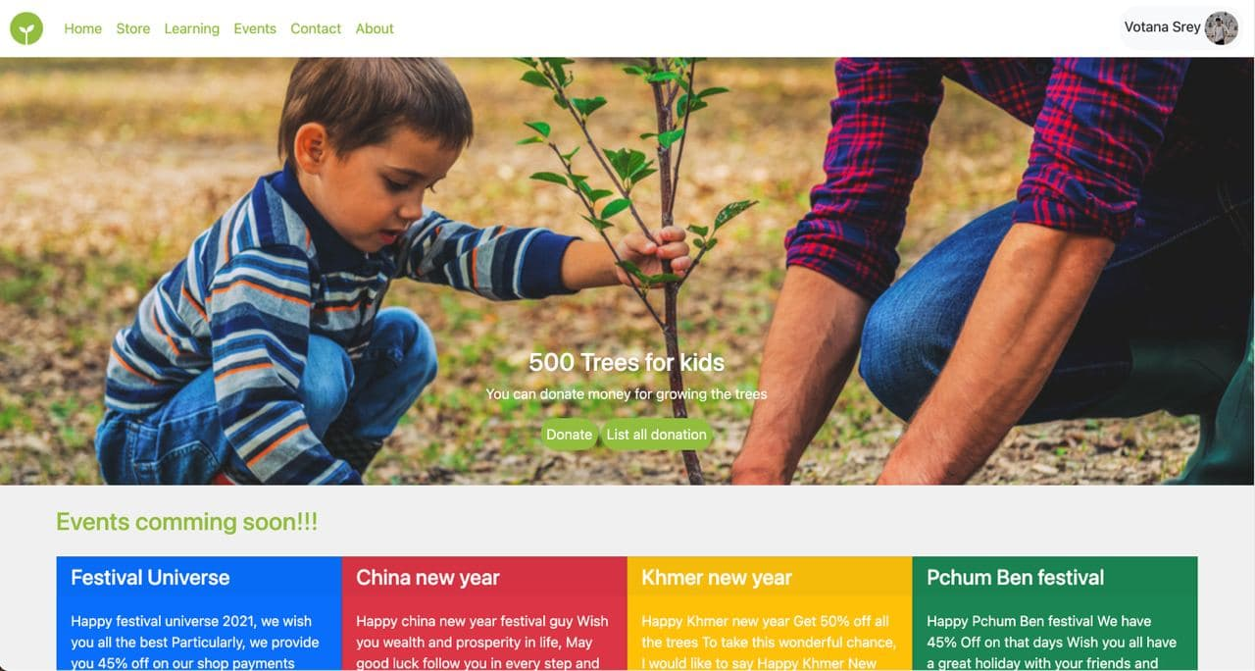

1. Medium page in our page

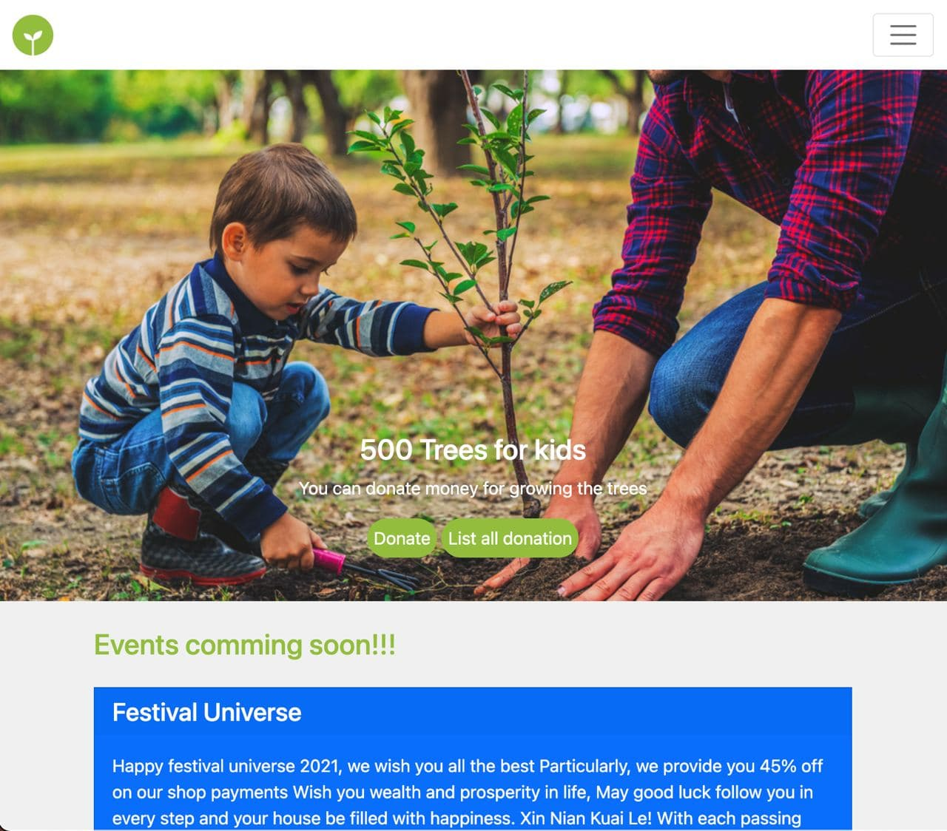

3.Small page in our web site

